ACADEMY: APEX TECH FORGE ACADEMY
PROJECT: APEX TECH FORGE PROJECT
NAME OF PARTICIPANTS:
- Alabi David Tolulope
- Sanni A. Eniola
- Odemakinde D. Peter
- Yakub Fathia Ajoke
- Olatobi O. Samuel
- Bamikole Phebe Oluwagbemisola

EMAIL: alabidavid2023@gmail.com
PROJECT
PHASE 1: THE THREAT ASSESSMENT AND POLICY
Action: Write a brief advisory report for the academy’s leadership
- Security Upgrade being critical for the academy’s survival: For every organization using an IoT devices, involving in the collection of personal information and likes requires an implementation of high security level. It isn’t possible to run away from threats or risks; especially schools, university and other organizations who dwell with a lot of people’s information. Security upgrades are critical for an academy's survival because they help protect the institution's people, information, finances, and reputation from threats and risks.
Based on the slight detect in phishing attempt and unauthorized network scanning, a requirement to upgrade the security systems will help to ensure the safety of students, teachers, and other staff members from falling for the deadly event. There should be the need of a physical control measures such as surveillance cameras, access control systems, turn-tiles, bollards and emergency response tools to reduce the risk of unauthorized access, violence, and other security incidents.
Based on the storage of large amounts of sensitive data, including student records, examination results, financial information, and staff details; the upgrade of security will protect these records from getting to the hands of an unauthorized individual, protect the records from cyberattacks and data breaches.
Attackers often target educational institutions based on their lackadaisical attention on security improvement. When a system is fully upgraded by implementing the necessary tools, it helps to prevent theft, fraud, ransomware attacks, and other incidents that could result in significant financial losses.
Maintaining Academic Operations Security incidents can disrupt teaching, examinations, and administrative activities. Upgraded security measures ensure that academic operations continue smoothly without interruptions caused by cyber or physical threats.
Educational institutions are often required to comply with data protection and security of their student and unfailingly to do so warrant a penalty for the academy. The protection of the academy reputations will be at stake if the security system isn’t upgraded.
A security breach can damage the academy's reputation and reduce trust among students, parents, staff, and stakeholders. Strong security demonstrates the institution's commitment to safety and professionalism.
To give my final conclusion, security upgrades are essential for an academy's long-term survival because they protect people, data, finances, and institutional credibility. Without continuous improvements to security, an academy becomes vulnerable to threats that can disrupt operations, cause financial damage, and undermine public trust.

- How the CIA Triad will be applied to protect student records: The CIA Triad (Confidentiality, Integrity, and Availability) is a fundamental cybersecurity framework that can be applied to protect student records in the academy. We can’t give a full explanation of this if the meaning of CIA isn’t defined; CIA stands for Confidentiality, Integrity and Availability that intertwine together to give a very strong bond in the security arena.
Confidentiality protects data and gives permit access to authorized individuals while preventing access to unauthorized individuals. Confidentiality ensures that student records are accessible only to authorized individuals.
Application:
- Use strong passwords and multi-factor authentication (MFA) for staff accounts.
- Encrypt (plain text to cipher text) student records both when stored and when transmitted.
- Implement role-based access control (RBAC) so that teachers, administrators, and students can only access information relevant to their roles.
- Regularly train staff on data privacy and security practices.
It protects sensitive information such as student grades, personal details, medical records, and financial information from unauthorized access.
Integrity ensures that student records remain accurate, complete, and unaltered unless authorized changes are made.
Application:
- Use audit logs to track who accesses or modifies records.
- Implement access controls that restrict editing privileges to authorized personnel.
- Use hashes, digital signatures, or database validation mechanisms to detect unauthorized changes.
- Regularly back up data and verify its accuracy.
It ensures that grades, attendance records, and personal information remain trustworthy and free from unauthorized modifications.
Availability ensures that student records are accessible whenever authorized users need them.
Application:
- Perform regular data backups and store copies in secure locations.
- Use reliable servers and network infrastructure.
- Implement disaster recovery and business continuity plans.
- Install antivirus software, firewalls, and system monitoring tools to reduce downtime caused by cyberattacks.
It allows students, teachers, and administrators to access records whenever needed, even during system failures or emergencies.

- Identify three realistic cyber threats the academy faces and propose one practical mitigation for each: The three realistic cyber threats are;
  - Phishing: Users awareness and Training
  - Ransomware: Regular Data Backup either off-site, on-site or cloud.
  - Dos/DDos: Deploy Firewall and Intrusion Detection System

PHASE 2: SECURE REMOTE ADMINISTRATION: Creating a secure and encrypted tunnel using ssh (22) between a host machine (Windows) and the target server (Linux VM).
We made SSH opened on our server (Linux VM) and we used Putty installed on our host machine to access the port 22 which is called the Secure Shell (ssh). We created a very secure and encrypted tunnel between the host machine and the server. We ran a Nmap command on the Host machine to confirm the assurance of the open port 22.

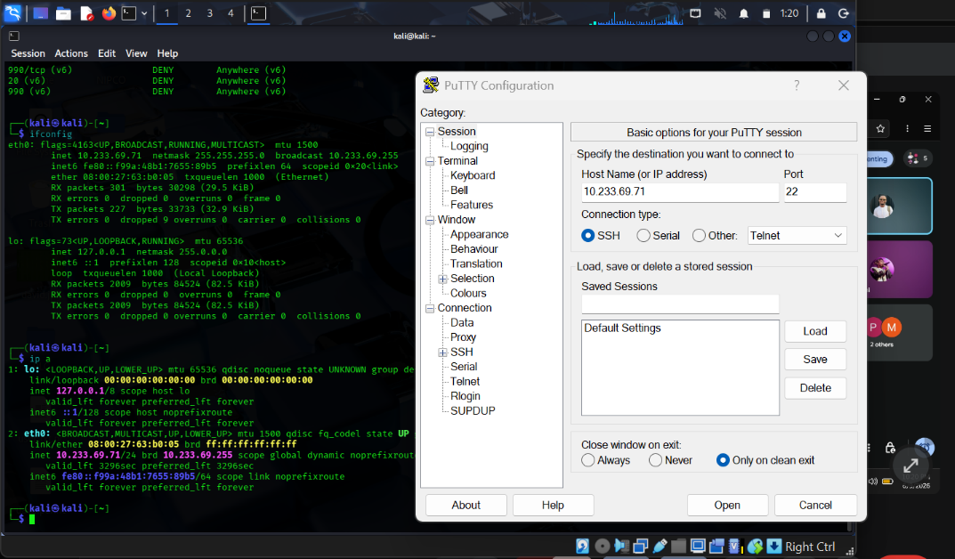
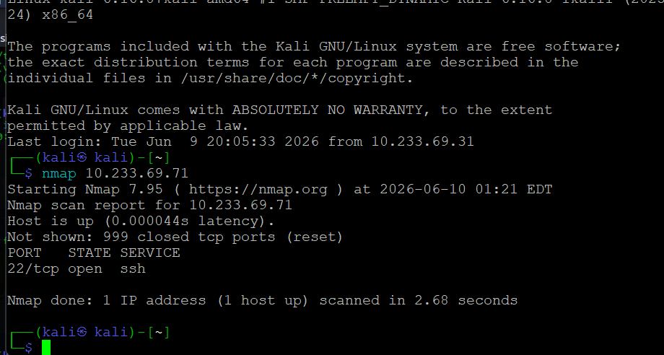

PHASE 3: DATA INTEGRITY VERIFICATION: A text file was created written in it some sensitive information about the company and making a hash of the file. The usefulness of the hash is to create an integrity for the file which is called “data integrity”. The hash created shows that the file has been algorithmized and if any alter is made, the data losses its integrity and it shows that an unauthorized access is made on the file.
We used a cryptographic hash of SHA256 and also changed the permission of the file using a “chmod 600” command to an owner only permit.
Why hashing is vital during incident response?
Hashing is a critical technique in incident response because it helps investigators verify the integrity, authenticity, and identification of digital evidence. It helps in evidence integrity verification, identification of malicious files, detection of unauthorized changes. Without hashing, investigators would have difficulty proving that digital evidence remained unchanged and trustworthy throughout the incident response process

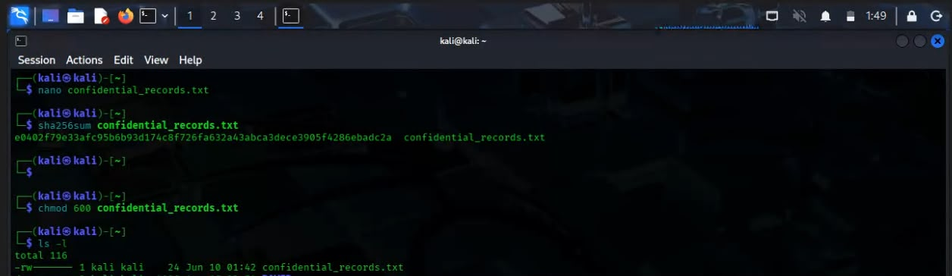

PHASE 4: NETWORK MONITORING AND VALIDATION: Wireshark used to capture the connection of putty and kali Linux (Server). The putty was connected to the server using port 22 which is the ssh service.
The ssh is an encrypted and secured port that keeps packets in a cipher text (Cryptography).
Why did firewalls act as a network choke point? It is because every packet has to go through it before reaching the rest of the network. When enabled, it serves as an intermediary between two networks, making it to check all traffics according to the rules set in it.

